Youth Stroke Education Toolkits: Teacher Notes & Lesson Plans

  - High School Presentations
The following lesson plans are meant to guide teachers in presenting the material based on the amount of time they have to dedicate to stroke education – 60min, 40min, or 20min. It is recommended that teachers use these presentations to supplement the cardiovascular unit curriculum of a high school health class.
In certain areas with corporate sponsors, guest speakers from the American Heart Association/American Stroke Association may be available to support presentations. Schools can contact their local Division of the AHA/ASA to inquire about this. However, these presentations are designed to be deliverable by teachers independent of AHA/ASA. All materials can be found at www.heart.org/youthstroketoolkits

  - Full Lesson Plan: 60min (use in block class schedule)
Slide 2: 15min overview of stroke & empathy activity #1
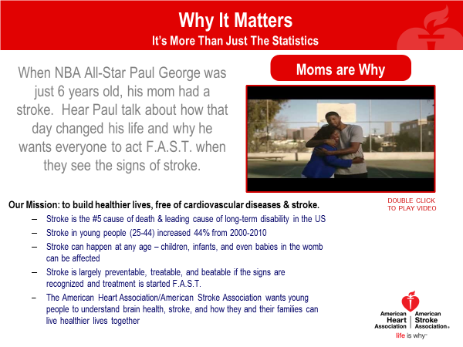
- We’re talking about this because stroke affects many people
  - Ask students to raise hands if they know someone affected by heart disease or stroke
  - Explain that heart health and brain health are connected
    - How much of heart disease and stroke is preventable? 80%
    - What are some actions we take to keep our hearts and brains healthy? Eating well, exercising, avoiding tobacco products, etc.
  - Heart disease is the #1 killer of Americans & stroke is #5
    - Ask students if they know what causes a stroke/what the 2 types of stroke are. Ischemic stroke is more common in the US (over 80% of strokes) and is caused when a blood vessel is blocked by a clot, reducing blood flow to the brain. Hemorrhagic stroke happens when a blood vessel bursts, leaking blood into the brain. Ischemic strokes are like clogged pipes, so keeping your blood vessels clean with healthy food and regular exercise helps prevent these. Hemorrhagic strokes are like burst pipes that break because they are too weak, so keeping your blood pressure low by eating less sodium helps prevent these.
    - Many people survive stroke (currently more than 6 million stroke survivors living in the US), but their lives are usually very different after stroke. Some people recover quickly and learn how to walk, talk, drive, and work again. Others don’t.
    - Stroke is also increasing in young people – why do you think that is? Overall health declining in young people due to poor diet, lack of physical activity, etc.
- This is not a scare tactic! This is meant to educate and empower you to make a difference
  - Ask students if they know any signs of stroke. Acronym F.A.S.T. helps us remember. F is for face drooping, A is for arm weakness/numbness, S is for speech difficulty, & T is for time to call 911.
  - In addition to F.A.S.T., other signs are the “suddens”: sudden severe headache, sudden change in vision, sudden dizziness, & sudden weakness/numbness on one side of body.
  - Why is it important to call 911 instead of driving to the hospital on your own, calling your neighbor to borrow their car, calling your mom to complain about your symptoms…? 911 operators/Emergency Medical Services can alert a hospital that you’re coming and get you treatment faster.
  - Why is fast treatment so important? When stroke happens, time is brain. Nearly 2 million brain cells die every minute during stroke! And building your brain back up after stroke takes a lot of work. Preventing it in the first place and/or getting it treated fast is the better way to go.
- Show Paul George video
  - Share that Paul was only 6 when his mom unexpectedly had a stroke.
  - Ask students if they noticed anything about his mom in the video.
  - Explain that her left side is still weak. She surely wants to hug her son with both arms, but the video only shows her right side facing the camera. Ask students what they think her left arm is doing. Tell them that they will now to an activity to simulate what living with stroke is like for some survivors.
- Finish with Empathy Activity #1 and ask students to consider what life would be like if everyday tasks were affected in this way.
  - Select 3 students and give them each a copy of this document:
  - Ask them all to get out a pencil or pen. Give the first student an oven mitt and the second student a pair of sunglasses. The third student gets no prop, but make sure that student is right handed.
  - Ask the first student to put on the oven mitt, then read Fact #1 and fill in the blanks. This activity simulates the word confusion and reduced fine motor control that some stroke survivors experience.
  - Ask the second student to put on the sunglasses and read Fact #2, then fill in the blanks. This activity simulates the darker/blurred vision that some stroke survivors experience.
  - Ask the third student to put the pencil or pen in the left hand, then read Fact #3 and fill in the blanks. This activity simulates hemianopsia (spots in visual field) and the loss of right-sided motor function. Stroke often affects the right side of the body and most of us are right-handed.
Slide 3: 10min healthy diet review & brain health quiz
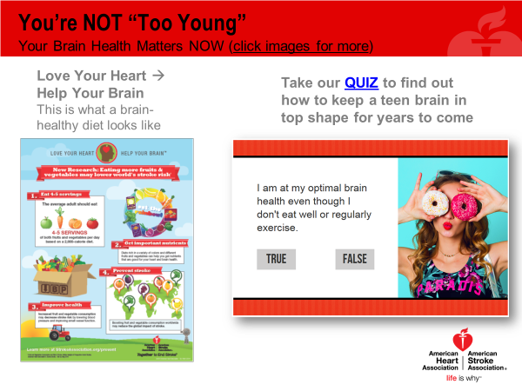
- Print and hand out “Love Your Heart, Help Your Brain” infographic and review healthy diet tips
- Click link to take Brain Health Quiz
  - Ask students to guess True or False on each question
  - Read out answers to each question
  - On the second to last question, have students stand up from their desks and try to balance on each leg for 20 seconds (added challenge: do it with eyes closed)
Slide 4: 5min detail on dietary sugar and sodium
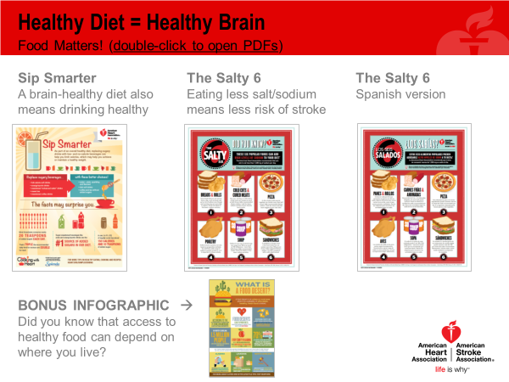
- Print and hand out “Sip Smarter” and “Salty 6” infographics
- Discuss the difference between restrictive dieting (hard to maintain and potentially dangerous) and choosing smart/healthy foods most of the time (a style of eating that emphasizes fresh, whole foods like fruits, vegetables, grains, and lean proteins over processed foods with added sugar and sodium)
- These topics often raise MANY questions. For supporting information, teachers can access AHA/ASA guidelines on dietary sugar and dietary sodium.
Slide 5: 30min video clips, empathy activity #2, & conclusion
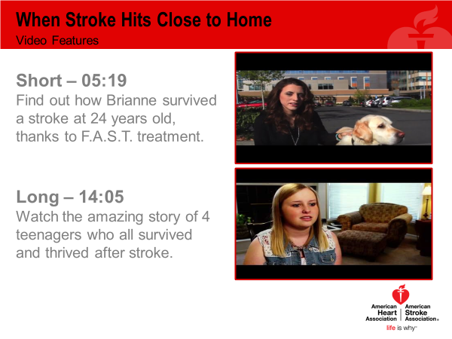
- Show both videos
  - First video is about a 24 year old survivor whose symptoms were recognized quickly, which resulted in fast treatment and good outcomes
  - Second video is about 4 teenagers in different parts of the country who became friends after each had a stroke. They all had different types of strokes and different challenges afterwards. But all 4 found comfort and strength in each other as “peer support”
- Finish with Empathy Activity #2
  - Select 2 students and tell them they will be racing against each other
  - Give the first student an arm sling to put on their dominant arm (or use masking tape to tape their arm to their side). Give the second student an oven mitt and a bottle of medication (or a pill bottle filled with breath mints) and have him or her spill the bottle out onto the desk.
  - Tell the first student that he or she will need to empty out an entire backpack without using the impaired arm. Tell the second student that he or she will need to put all of the pills back into the bottle and close it while wearing the oven mitt.
  - Start the students on the activity at the same time and use a stopwatch to time them. Give a small prize to the student who does the activity faster.
  - Ask the rest of the class what they observed. Did the students get frustrated? Did they ask anyone for help? Did they take a long time or find a creative way to do the activity faster? What would life be like if this were an everyday occurrence?
- In closing: stroke affects 800,000 people in America every year. It can be prevented with healthy habits, treated if recognized fast enough, and beaten with courage and adequate rehab. But stroke changes peoples’ lives and the lives of their loved ones. So, remember F.A.S.T. and remember to be patient and empathetic if you encounter a stroke survivor.

  - Abbreviated Lesson Plan: 40min (use in traditional class schedule)
Slide 2: 15min overview of stroke & empathy activity #1
- We’re talking about this because stroke affects many people
  - Ask students to raise hands if they know someone affected by heart disease or stroke
  - Explain that heart health and brain health are connected
    - How much of heart disease and stroke is preventable? 80%
    - What are some actions we take to keep our hearts and brains healthy? Eating well, exercising, avoiding tobacco products, etc.
  - Heart disease is the #1 killer of Americans & stroke is #5
    - Ask students if they know what causes a stroke/what the 2 types of stroke are. Ischemic stroke is more common in the US (over 80% of strokes) and is caused when a blood vessel is blocked by a clot, reducing blood flow to the brain. Hemorrhagic stroke happens when a blood vessel bursts, leaking blood into the brain. Ischemic strokes are like clogged pipes, so keeping your blood vessels clean with healthy food and regular exercise helps prevent these. Hemorrhagic strokes are like burst pipes that break because they are too weak, so keeping your blood pressure low by eating less sodium helps prevent these.
    - Many people survive stroke (currently more than 6 million stroke survivors living in the US), but their lives are usually very different after stroke. Some people recover quickly and learn how to walk, talk, drive, and work again. Others don’t.
    - Stroke is also increasing in young people – why do you think that is? Overall health declining in young people due to poor diet, lack of physical activity, etc.
- This is not a scare tactic! This is meant to educate and empower you to make a difference
  - Ask students if they know any signs of stroke. Acronym F.A.S.T. helps us remember. F is for face drooping, A is for arm weakness/numbness, S is for speech difficulty, & T is for time to call 911.
  - In addition to F.A.S.T., other signs are the “suddens”: sudden severe headache, sudden change in vision, sudden dizziness, & sudden weakness/numbness on one side of body.
  - Why is it important to call 911 instead of driving to the hospital on your own, calling your neighbor to borrow their car, calling your mom to complain about your symptoms…? 911 operators/Emergency Medical Services can alert a hospital that you’re coming and get you treatment faster.
  - Why is fast treatment so important? When stroke happens, time is brain. Nearly 2 million brain cells die every minute during stroke! And building your brain back up after stroke takes a lot of work. Preventing it in the first place and/or getting it treated fast is the better way to go.
- Show Paul George video
  - Share that Paul was only 6 when his mom unexpectedly had a stroke.
  - Ask students if they noticed anything about his mom in the video.
  - Explain that her left side is still weak. She surely wants to hug her son with both arms, but the video only shows her right side facing the camera. Ask students what they think her left arm is doing. Tell them that they will now to an activity to simulate what living with stroke is like for some survivors.
- Finish with Empathy Activity #1 and ask students to consider what life would be like if everyday tasks were affected in this way.
  - Select 3 students and give them each a copy of this document:
  - Ask them all to get out a pencil or pen. Give the first student an oven mitt and the second student a pair of sunglasses. The third student gets no prop, but make sure that student is right handed.
  - Ask the first student to put on the oven mitt, then read Fact #1 and fill in the blanks. This activity simulates the word confusion and reduced fine motor control that some stroke survivors experience.
  - Ask the second student to put on the sunglasses and read Fact #2, then fill in the blanks. This activity simulates the darker/blurred vision that some stroke survivors experience.
  - Ask the third student to put the pencil or pen in the left hand, then read Fact #3 and fill in the blanks. This activity simulates hemianopsia (spots in visual field) and the loss of right-sided motor function. Stroke often affects the right side of the body and most of us are right-handed.
Slide 3: 5min brain health quiz
- Click link to take Brain Health Quiz
  - Ask students to guess True or False on each question
  - Read out answers to each question
  - On the second to last question, have students stand up from their desks and try to balance on each leg for 20 seconds (added challenge: do it with eyes closed)
Slide 5: 20min video clips, empathy activity #2, & conclusion
- Show first video
  - First video is about a 24 year old survivor whose symptoms were recognized quickly, which resulted in fast treatment and good outcomes
  - Second video is about 4 teenagers in different parts of the country who became friends after each had a stroke. They all had different types of strokes and different challenges afterwards. But all 4 found comfort and strength in each other as “peer support”
- Finish with Empathy Activity #2
  - Select 2 students and tell them they will be racing against each other
  - Give the first student an arm sling to put on their dominant arm (or use masking tape to tape their arm to their side). Give the second student an oven mitt and a bottle of medication (or a pill bottle filled with breath mints) and have him or her spill the bottle out onto the desk.
  - Tell the first student that he or she will need to empty out an entire backpack without using the impaired arm. Tell the second student that he or she will need to put all of the pills back into the bottle and close it while wearing the oven mitt.
  - Start the students on the activity at the same time and use a stopwatch to time them. Give a small prize to the student who does the activity faster.
  - Ask the rest of the class what they observed. Did the students get frustrated? Did they ask anyone for help? Did they take a long time or find a creative way to do the activity faster? What would life be like if this were an everyday occurrence?
- In closing: stroke affects 800,000 people in America every year. It can be prevented with healthy habits, treated if recognized fast enough, and beaten with courage and adequate rehab. But stroke changes peoples’ lives and the lives of their loved ones. So, remember F.A.S.T. and remember to be patient and empathetic if you encounter a stroke survivor.

  - Mini Lesson Plan: 20min (use as part of larger lesson plan)
Slide 2: 15min overview of stroke & empathy activity #1
- We’re talking about this because stroke affects many people
  - Ask students to raise hands if they know someone affected by heart disease or stroke
  - Explain that heart health and brain health are connected
    - How much of heart disease and stroke is preventable? 80%
    - What are some actions we take to keep our hearts and brains healthy? Eating well, exercising, avoiding tobacco products, etc.
  - Heart disease is the #1 killer of Americans & stroke is #5
    - Ask students if they know what causes a stroke/what the 2 types of stroke are. Ischemic stroke is more common in the US (over 80% of strokes) and is caused when a blood vessel is blocked by a clot, reducing blood flow to the brain. Hemorrhagic stroke happens when a blood vessel bursts, leaking blood into the brain. Ischemic strokes are like clogged pipes, so keeping your blood vessels clean with healthy food and regular exercise helps prevent these. Hemorrhagic strokes are like burst pipes that break because they are too weak, so keeping your blood pressure low by eating less sodium helps prevent these.
    - Many people survive stroke (currently more than 6 million stroke survivors living in the US), but their lives are usually very different after stroke. Some people recover quickly and learn how to walk, talk, drive, and work again. Others don’t.
    - Stroke is also increasing in young people – why do you think that is? Overall health declining in young people due to poor diet, lack of physical activity, etc.
- This is not a scare tactic! This is meant to educate and empower you to make a difference
  - Ask students if they know any signs of stroke. Acronym F.A.S.T. helps us remember. F is for face drooping, A is for arm weakness/numbness, S is for speech difficulty, & T is for time to call 911.
  - In addition to F.A.S.T., other signs are the “suddens”: sudden severe headache, sudden change in vision, sudden dizziness, & sudden weakness/numbness on one side of body.
  - Why is it important to call 911 instead of driving to the hospital on your own, calling your neighbor to borrow their car, calling your mom to complain about your symptoms…? 911 operators/Emergency Medical Services can alert a hospital that you’re coming and get you treatment faster.
  - Why is fast treatment so important? When stroke happens, time is brain. Nearly 2 million brain cells die every minute during stroke! And building your brain back up after stroke takes a lot of work. Preventing it in the first place and/or getting it treated fast is the better way to go.
- Show Paul George video
  - Share that Paul was only 6 when his mom unexpectedly had a stroke.
  - Ask students if they noticed anything about his mom in the video.
  - Explain that her left side is still weak. She surely wants to hug her son with both arms, but the video only shows her right side facing the camera. Ask students what they think her left arm is doing. Tell them that they will now to an activity to simulate what living with stroke is like for some survivors.
- Finish with Empathy Activity #1 and ask students to consider what life would be like if everyday tasks were affected in this way.
  - Select 3 students and give them each a copy of this document:
  - Ask them all to get out a pencil or pen. Give the first student an oven mitt and the second student a pair of sunglasses. The third student gets no prop, but make sure that student is right handed.
  - Ask the first student to put on the oven mitt, then read Fact #1 and fill in the blanks. This activity simulates the word confusion and reduced fine motor control that some stroke survivors experience.
  - Ask the second student to put on the sunglasses and read Fact #2, then fill in the blanks. This activity simulates the darker/blurred vision that some stroke survivors experience.
  - Ask the third student to put the pencil or pen in the left hand, then read Fact #3 and fill in the blanks. This activity simulates hemianopsia (spots in visual field) and the loss of right-sided motor function. Stroke often affects the right side of the body and most of us are right-handed.
Slide 3: 5min brain health quiz
- Click link to take Brain Health Quiz
  - Ask students to guess True or False on each question
  - Read out answers to each question
  - On the second to last question, have students stand up from their desks and try to balance on each leg for 20 seconds (added challenge: do it with eyes closed)
Slide 5: HOMEWORK & conclusion
- Instruct students to watch one or both videos as HOMEWORK
  - First video is about a 24 year old survivor whose symptoms were recognized quickly, which resulted in fast treatment and good outcomes
  - Second video is about 4 teenagers in different parts of the country who became friends after each had a stroke. They all had different types of strokes and different challenges afterwards. But all 4 found comfort and strength in each other as “peer support”
- In the next class session
  - Discuss their thoughts and reactions
  - In closing: stroke affects 800,000 people in America every year. It can be prevented with healthy habits, treated if recognized fast enough, and beaten with courage and adequate rehab. But stroke changes peoples’ lives and the lives of their loved ones. So, remember F.A.S.T. and remember to be patient and empathetic if you encounter a stroke survivor.

  - Middle School Presentations
The following lesson plans are meant to guide teachers in presenting the material based on the amount of time they have to dedicate to stroke education – either 40min or 20min. It is recommended that teachers integrate this material into a health or physical sciences class.
In certain areas with corporate sponsors, guest speakers from the American Heart Association/American Stroke Association may be available to support presentations. Schools can contact their local Division of the AHA/ASA to inquire about this. However, these presentations are designed to be deliverable by teachers independent of AHA/ASA. All materials can be found at www.heart.org/youthstroketoolkits

  - Full Lesson Plan: 40min
Slide 2: 20min overview of stroke & empathy activity #1
- We’re talking about this because stroke affects many people
  - Ask students to raise hands if they know someone affected by heart disease or stroke
  - Explain that heart health and brain health are connected
    - How much of heart disease and stroke is preventable? 80%
    - What are some actions we take to keep our hearts and brains healthy? Eating well, exercising, avoiding tobacco products, etc.
  - Heart disease is the #1 killer of Americans & stroke is #5
    - Ask students if they know what causes a stroke/what the 2 types of stroke are. Ischemic stroke is more common in the US (over 80% of strokes) and is caused when a blood vessel is blocked by a clot, reducing blood flow to the brain. Hemorrhagic stroke happens when a blood vessel bursts, leaking blood into the brain. Ischemic strokes are like clogged pipes, so keeping your blood vessels clean with healthy food and regular exercise helps prevent these. Hemorrhagic strokes are like burst pipes that break because they are too weak, so keeping your blood pressure low by eating less sodium helps prevent these.
    - Many people survive stroke (currently more than 6 million stroke survivors living in the US), but their lives are usually very different after stroke. Some people recover quickly and learn how to walk, talk, drive, and work again. Others don’t.
    - Stroke is also increasing in young people – why do you think that is? Overall health declining in young people due to poor diet, lack of physical activity, etc.
- This is not a scare tactic! This is meant to educate and empower you to make a difference
  - Ask students if they know any signs of stroke. Acronym F.A.S.T. helps us remember. F is for face drooping, A is for arm weakness/numbness, S is for speech difficulty, & T is for time to call 911.
  - In addition to F.A.S.T., other signs are the “suddens”: sudden severe headache, sudden change in vision, sudden dizziness, & sudden weakness/numbness on one side of body.
  - Why is it important to call 911 instead of driving to the hospital on your own, calling your neighbor to borrow their car, calling your mom to complain about your symptoms…? 911 operators/Emergency Medical Services can alert a hospital that you’re coming and get you treatment faster.
  - Why is fast treatment so important? When stroke happens, time is brain. Nearly 2 million brain cells die every minute during stroke! And building your brain back up after stroke takes a lot of work. Preventing it in the first place and/or getting it treated fast is the better way to go.
- Show Paul George video
  - Share that Paul was only 6 when his mom unexpectedly had a stroke.
  - Ask students if they noticed anything about his mom in the video.
  - Explain that her left side is still weak. She surely wants to hug her son with both arms, but the video only shows her right side facing the camera. Ask students what they think her left arm is doing. Tell them that they will now to an activity to simulate what living with stroke is like for some survivors.
- Finish with Empathy Activity #1 and ask students to consider what life would be like if everyday tasks were affected in this way.
  - Select 3 students and give them each a copy of this document:
  - Ask them all to get out a pencil or pen. Give the first student an oven mitt and the second student a pair of sunglasses. The third student gets no prop, but make sure that student is right handed.
  - Ask the first student to put on the oven mitt, then read Fact #1 and fill in the blanks. This activity simulates the word confusion and reduced fine motor control that some stroke survivors experience.
  - Ask the second student to put on the sunglasses and read Fact #2, then fill in the blanks. This activity simulates the darker/blurred vision that some stroke survivors experience.
  - Ask the third student to put the pencil or pen in the left hand, then read Fact #3 and fill in the blanks. This activity simulates hemianopsia (spots in visual field) and the loss of right-sided motor function. Stroke often affects the right side of the body and most of us are right-handed.
Slide 3: 5min healthy diet review
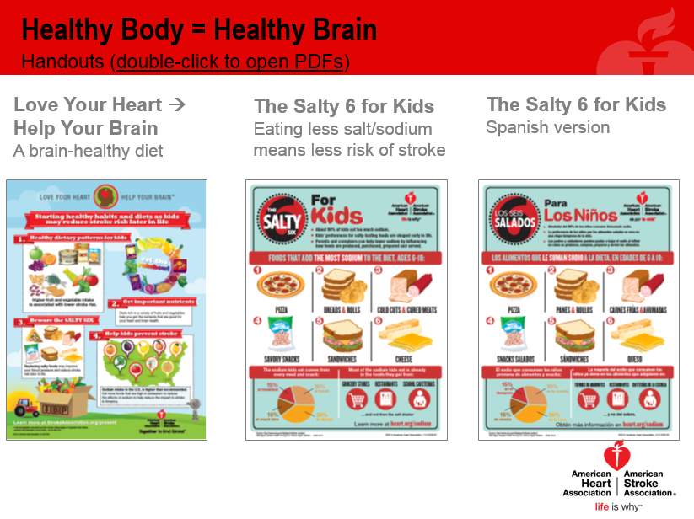
- Print and hand out “Love Your Heart, Help Your Brain” & “Salty 6 for Kids” infographics
- Discuss the difference between restrictive dieting (hard to maintain and potentially dangerous) and choosing smart/healthy foods most of the time (a style of eating that emphasizes fresh, whole foods like fruits, vegetables, grains, and lean proteins over processed foods with added sugar and sodium)
- These topics often raise MANY questions. For supporting information, teachers can access AHA/ASA guidelines on dietary sugar and dietary sodium.
Slide 4: 5min activity
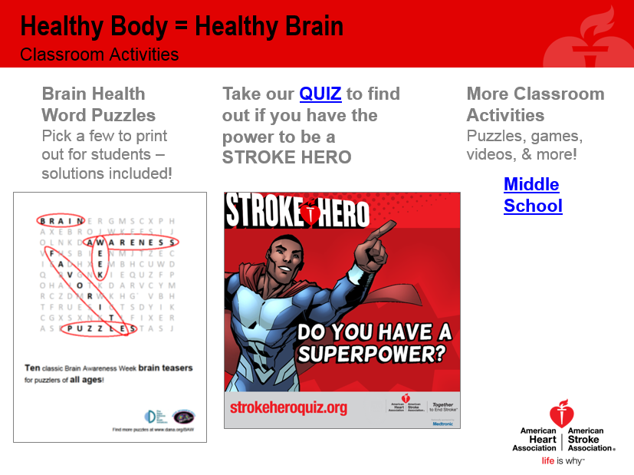
- Choose an activity from one of the three options on the slide – the word puzzles will need to be printed, the quiz can be done online, and the other activities will vary in the preparation needed
Slide 5: 5min video clip, empathy activity #2, & conclusion
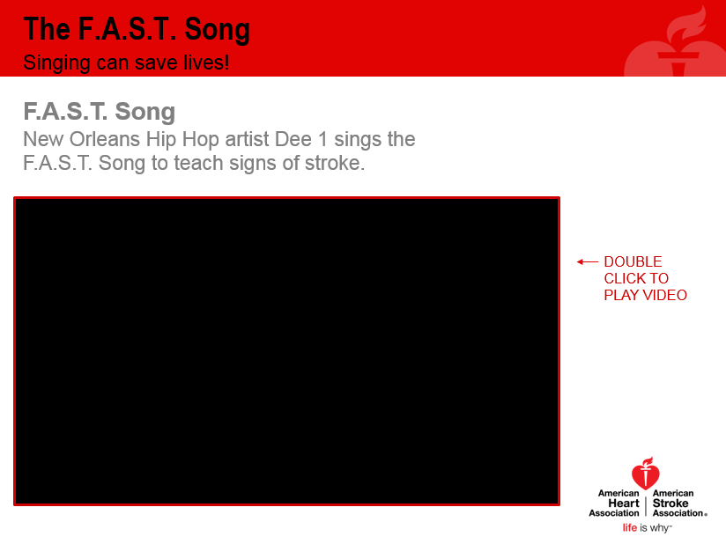
- Show the video as a reminder of the F.A.S.T. warning signs
- Finish with Empathy Activity #2
  - Select 2 students and tell them they will be racing against each other
  - Give the first student an arm sling to put on their dominant arm (or use masking tape to tape their arm to their side). Give the second student an oven mitt and a bottle of medication (or a pill bottle filled with breath mints) and have him or her spill the bottle out onto the desk.
  - Tell the first student that he or she will need to empty out an entire backpack without using the impaired arm. Tell the second student that he or she will need to put all of the pills back into the bottle and close it while wearing the oven mitt.
  - Start the students on the activity at the same time and use a stopwatch to time them. Give a small prize to the student who does the activity faster.
  - Ask the rest of the class what they observed. Did the students get frustrated? Did they ask anyone for help? Did they take a long time or find a creative way to do the activity faster? What would life be like if this were an everyday occurrence?
- In closing: stroke affects 800,000 people in America every year. It can be prevented with healthy habits, treated if recognized fast enough, and beaten with courage and adequate rehab. But stroke changes peoples’ lives and the lives of their loved ones. So, remember F.A.S.T. and remember to be patient and empathetic if you encounter a stroke survivor.

  - Abbreviated Lesson Plan: 20min
Slide 2: 10min overview of stroke
- We’re talking about this because stroke affects many people
  - Ask students to raise hands if they know someone affected by heart disease or stroke
  - Explain that heart health and brain health are connected
    - How much of heart disease and stroke is preventable? 80%
    - What are some actions we take to keep our hearts and brains healthy? Eating well, exercising, avoiding tobacco products, etc.
  - Heart disease is the #1 killer of Americans & stroke is #5
    - Ask students if they know what causes a stroke/what the 2 types of stroke are. Ischemic stroke is more common in the US (over 80% of strokes) and is caused when a blood vessel is blocked by a clot, reducing blood flow to the brain. Hemorrhagic stroke happens when a blood vessel bursts, leaking blood into the brain. Ischemic strokes are like clogged pipes, so keeping your blood vessels clean with healthy food and regular exercise helps prevent these. Hemorrhagic strokes are like burst pipes that break because they are too weak, so keeping your blood pressure low by eating less sodium helps prevent these.
    - Many people survive stroke (currently more than 6 million stroke survivors living in the US), but their lives are usually very different after stroke. Some people recover quickly and learn how to walk, talk, drive, and work again. Others don’t.
    - Stroke is also increasing in young people – why do you think that is? Overall health declining in young people due to poor diet, lack of physical activity, etc.
- This is not a scare tactic! This is meant to educate and empower you to make a difference
  - Ask students if they know any signs of stroke. Acronym F.A.S.T. helps us remember. F is for face drooping, A is for arm weakness/numbness, S is for speech difficulty, & T is for time to call 911.
  - In addition to F.A.S.T., other signs are the “suddens”: sudden severe headache, sudden change in vision, sudden dizziness, & sudden weakness/numbness on one side of body.
  - Why is it important to call 911 instead of driving to the hospital on your own, calling your neighbor to borrow their car, calling your mom to complain about your symptoms…? 911 operators/Emergency Medical Services can alert a hospital that you’re coming and get you treatment faster.
  - Why is fast treatment so important? When stroke happens, time is brain. Nearly 2 million brain cells die every minute during stroke! And building your brain back up after stroke takes a lot of work. Preventing it in the first place and/or getting it treated fast is the better way to go.
- Show Paul George video
  - Share that Paul was only 6 when his mom unexpectedly had a stroke.
  - Ask students if they noticed anything about his mom in the video.
  - Explain that her left side is still weak. She surely wants to hug her son with both arms, but the video only shows her right side facing the camera. Ask students what they think her left arm is doing. Tell them that they will now to an activity to simulate what living with stroke is like for some survivors.
Slide 3: 5min healthy diet review
- Print and hand out “Love Your Heart, Help Your Brain” & “Salty 6 for Kids” infographics
- Discuss the difference between restrictive dieting (hard to maintain and potentially dangerous) and choosing smart/healthy foods most of the time (a style of eating that emphasizes fresh, whole foods like fruits, vegetables, grains, and lean proteins over processed foods with added sugar and sodium)
- These topics often raise MANY questions. For supporting information, teachers can access AHA/ASA guidelines on dietary sugar and dietary sodium.
Slide 5: 5min video clip, empathy activity #2, & conclusion
- Show the video as a reminder of the F.A.S.T. warning signs
- Finish with Empathy Activity #2
  - Select 2 students and tell them they will be racing against each other
  - Give the first student an arm sling to put on their dominant arm (or use masking tape to tape their arm to their side). Give the second student an oven mitt and a bottle of medication (or a pill bottle filled with breath mints) and have him or her spill the bottle out onto the desk.
  - Tell the first student that he or she will need to empty out an entire backpack without using the impaired arm. Tell the second student that he or she will need to put all of the pills back into the bottle and close it while wearing the oven mitt.
  - Start the students on the activity at the same time and use a stopwatch to time them. Give a small prize to the student who does the activity faster.
  - Ask the rest of the class what they observed. Did the students get frustrated? Did they ask anyone for help? Did they take a long time or find a creative way to do the activity faster? What would life be like if this were an everyday occurrence?
- In closing: stroke affects 800,000 people in America every year. It can be prevented with healthy habits, treated if recognized fast enough, and beaten with courage and adequate rehab. But stroke changes peoples’ lives and the lives of their loved ones. So, remember F.A.S.T. and remember to be patient and empathetic if you encounter a stroke survivor.

