Past Recipients of the James H. Gilliam, Jr. Award:

2005: Governor Ruth Ann Minner

2006: Dr. Gerald Lemole

2007: Dr. Arthur & Mrs. Mary Colburn

2008: Ms. JoAnn Desilits

2009: Dr. Kathleen W. McNicholas  
2010: Award not given

2011: Dr. Timothy Gardner

2012: Mr. Charles Welch

2013: Michele Rollins

2014: Mr. Victor Battaglia, Sr., Esq.

2015: Mr. Gary Stockbridge

2016: Mr. Thomas L. Sager, Esq.

2017: Ms. Dian C. Taylor

2018: Mr. Michael & Mrs. Ericka Hynansky

Please remember the American Heart Association in your will.

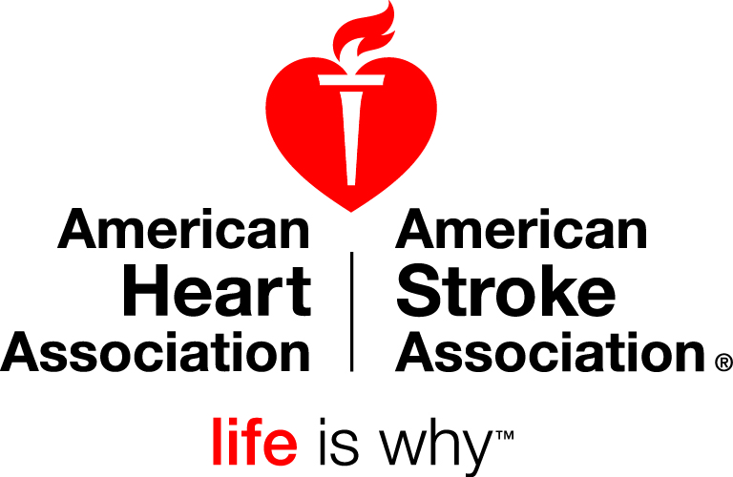

200 Continental Drive, Suite 101

Newark, DE 19713

Tel 877-750-4276

Tel 302-454-0613

Fax 302-454-0619

www.americanheart.org

