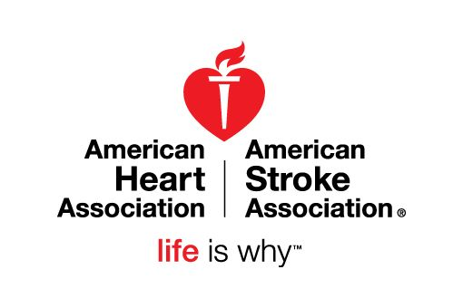

AHA Young Professionals

Jessica Barrett
Abbott Laboratories

Jasmine Bennings
PNC

Kim Bizal
UPMC

Sommer DeRose
Faster Fitness
Montour School District

Carissa Janczewski
Grossman Yanak & Ford

Stefanie Lacy
K&L Gates

Cheryl Lewis
Propel Schools

Juanita Lomax
Highmark

Gina Madison
PNC

Erin Morehouse
The Boston Consulting Group

Paige Myers
Hotel Monaco

Kam Niskach
Kam Jamz LLC
Beachbody LIVE

Tara Noland
PJ Dick

Jessica Pollick
Magee Women’s Hospital

Sara Pompilio
Kelly Services

Julia Ryan
Allegheny Health Network

Amanda Schaub
Otis Elevator Company

Lauren Shaffer
GNC

Tia Sharp
UPMC

Diana Stecko
K&L Gates

Kathleen Sweat
Gatesman Agency

